NB-IoT Efento Sensor offline? Here’s how to check the status and restore the connection
When a sensor stops transmitting data, there may be several possible causes: an issue with the network, a malfunction within the device itself, or the sensor may have been accidentally turned off.
Please follow the steps below to check whether the sensor is still active and to manually resolve any potential errors. This will help us quickly assess the situation and determine the next steps.

Preparation:
- Install the Efento App on an Android device via the Google Play Store
- Make sure you are physically near the sensor
- Enable Bluetooth on your Android device

Step 1: Check the Cellular Status of the Device
- Open the Efento App
- Find the relevant sensor in the list and connect to it
- Go to the "Device info" or "Status" menu
- Review the cellular status:
  - Is the device connected to the network?
  - What is the signal strength?
  - Are there any error messages or connection issues?

Step 2: Reset the Cellular Module of the Sensor
- While connected to the sensor in the app, navigate to "Advanced" or "Settings"
- Select "Reset cellular module"
- Confirm the action when prompted
- The sensor will attempt to re-establish a connection with the cellular network

Important Note:
Efento sensors are equipped with a built-in mechanism that automatically reboots the device if no valid data transmission occurs for more than 2 days. However, we strongly recommend performing this manual check as soon as possible once you notice the sensor is no longer sending data.
Please let us know what you see in the app after completing these steps so we can provide further assistance or follow-up.
If you need help during this process, don’t hesitate to contact us.

1.) Cellular status of the device.
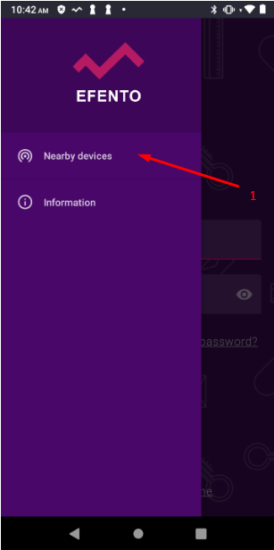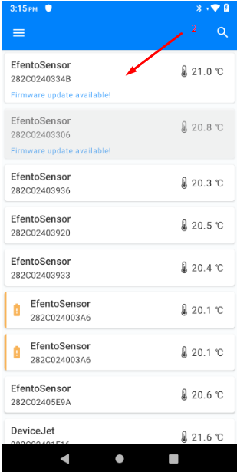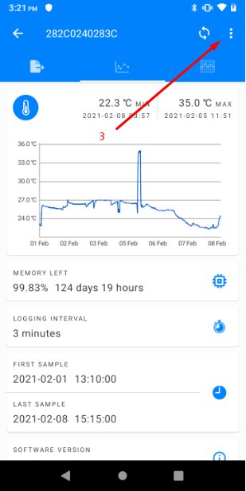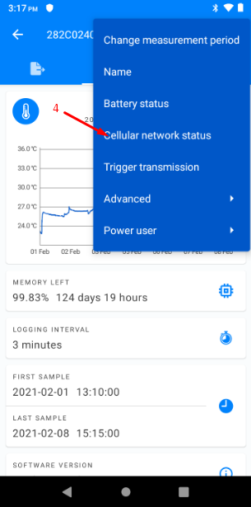

2.) Reset cellular module.
