

EasyLog Cloud Setup Instructions
With the steps below, you can correctly configure your EasyLog datalogger via the EasyLog Cloud. Follow the instructions carefully to set up your device and configure alarm notifications.

1) Setting the Parameters
- Select your device from the list and click the gear icon to open the Device Settings.
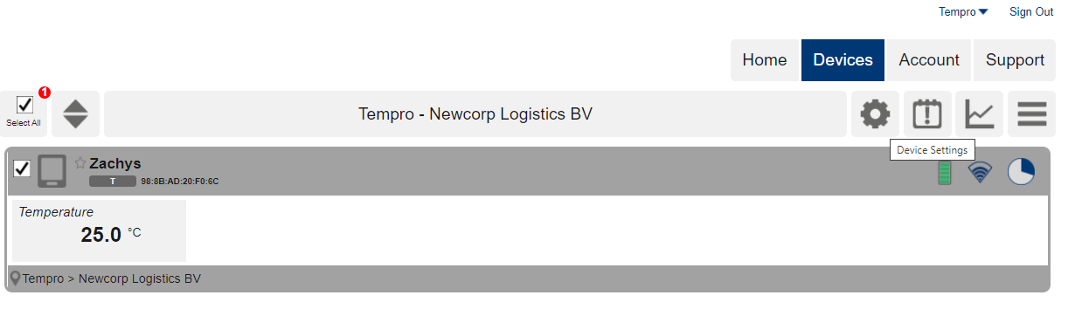
a. Properties
- Assign a recognizable name to the device.
- Set the sample rate: this determines how often the logger takes a measurement.
- Define the sync schedule: this determines how often the logger sends data to the cloud.
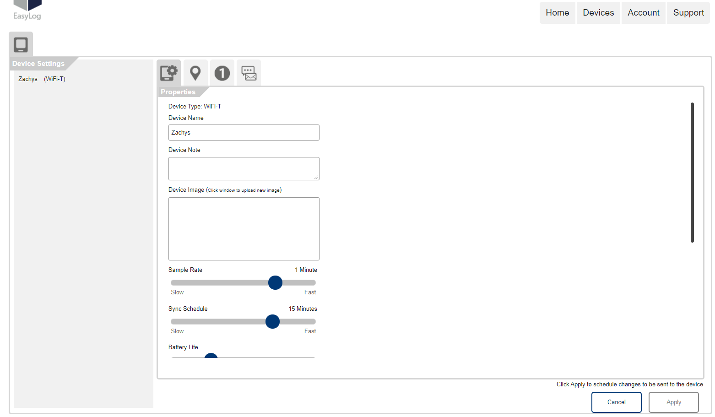
- At the bottom, you can open the Advanced Settings:
  - Here you can, for example, indicate whether the device is permanently powered via a mains power adapter (Permanently Powered).
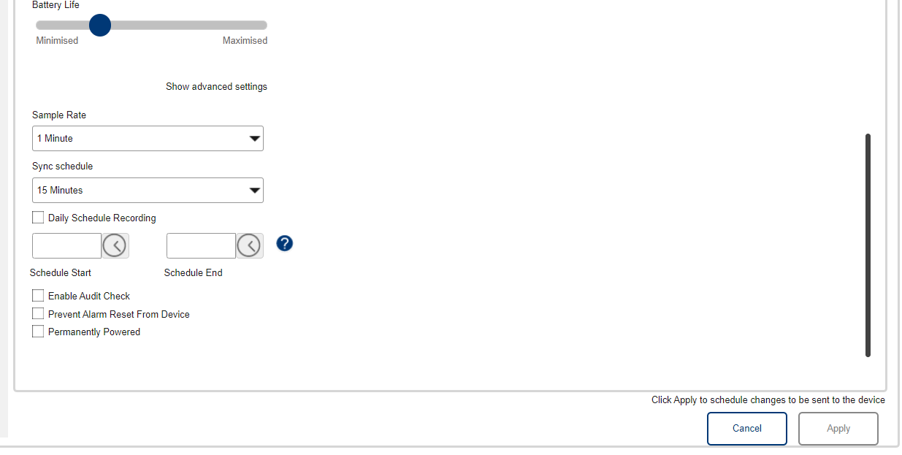
b. Alarm Settings
- Set the low and high alarm thresholds per channel.
- If required, add an alarm delay so that short fluctuations (such as opening a door) do not trigger an immediate alarm.
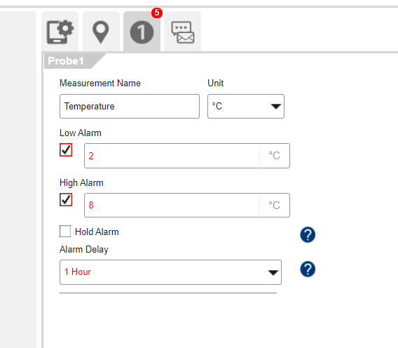
c. Notifications
- Define who receives which notifications for each type of alarm.
- You can select multiple users to receive email notifications when an alarm condition occurs.
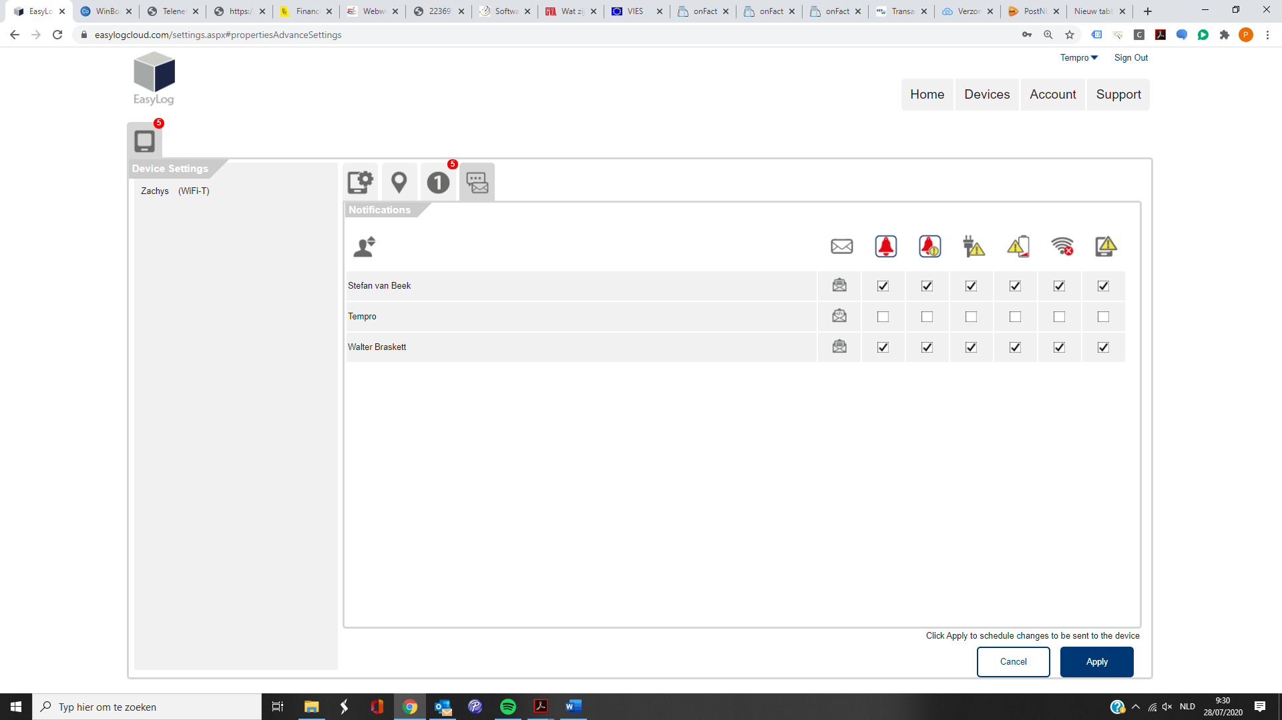
2) Applying the Settings
- After adjusting the configuration, click Apply.
- The new settings will be automatically sent to the logger during the next synchronization.

For more tips & tricks, visit:
https://www.tempro.be/blog/tempro-easylog-cloud-11
Happy monitoring!
Dataloggers.shop

